Torment Card Preview: Grim Lavamancer
David Price
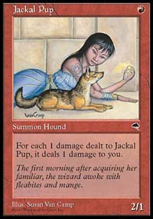
For the most part, when a red mage summons creatures, they tend to be of one of two types. Some red mages unleash especially damaging creatures that have drawbacks, some drawbacks more significant than others. Jackal Pup is one such creature, a 2/1 for only one red mana. The Pup's drawback was considered relatively minor by tournament players; whenever a Jackal Pup receives damage, it deals an equal amount of damage to its controller. Jackal Pup became the core of fast, aggressive red decks that were designed to deal damage to the opponent as quickly and efficiently as possible. Along with Jackal Pup, there was often Mogg Flunkies, 3/3 creatures for that could only attack or block if they were accompanied by another creature. Ball Lightning, a 6/1 trampler for , could deal a terrific amount of damage in a short amount of time, even if it did die at the end of the turn. On the less popular end of the spectrum, there are creatures like Lava Hounds and Okk.
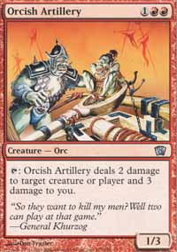
Despite what some beatdown players would like you to believe, there is also another type of red creature that is widely used and respected. Before the era of Jackal Pup, red decks contained creatures with less power for their casting cost, but with useful abilities that could help deal with opposing creatures and often the opponent. Orcish Artillery, a 1/3 creature for , seems like a sad creature indeed. However, his ability was quite useful. He could tap himself to deal two damage to a creature or player and three damage to the Orcish Artillery's controller. While potentially dangerous to use, it was an excellent tool for dealing with the opponent's creatures, and in the event of a creature stalemate, dealing the last few points to the opponent. At the same time that Jackal Pup entered the scene, his often overlooked friends, Mogg Fanatic and Fireslinger, joined the red player's arsenal. Mogg Fanatic, a 1/1 for one red mana, was reasonably efficient at dealing damage to the opponent and it could also be sacrificed to deal one point of damage to a creature or player. Similarly, Fireslinger, a 1/1 for , while less efficient than Mogg Fanatic, could tap himself to deal a point to a creature or player and a point to Fireslinger's controller. Fireslinger could be repeatedly used to deal with creatures or to damage the opponent despite a creature stalemate.
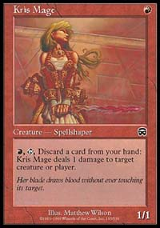
Even more recently, Mercadian Masques brought the red player Kris Mage, which shared characteristics with both Mogg Fanatic and Fireslinger from Tempest. Like Mogg Fanatic, Kris Mage is a 1/1 creature for one red mana, capable of being cast on the first turn and dealing some damage before the opponent can get his defenses up. Like Fireslinger, Kris Mage can repeatedly deal damage to creatures and the opponent, although the cost is a bit steeper, requiring the controller to discard a card from his or her hand upon activation of its ability.
With Kris Mage recently departed from the Standard environment, aggressive red decks have been lacking in one casting cost creatures. Luckily, Torment has stepped up to fill the void. Grim Lavamancer is an outstanding new creature from Torment that surpasses the strength of Kris Mage. At 1/1 for , he can still enter play on the first turn and began annoying the opponent. In addition, later in the game, Grim Lavamancer can tap and remove two cards from the graveyard to deal two points of damage to a creature of player.
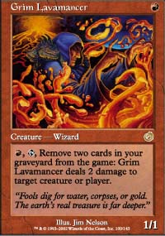
Grim Lavamancer's primary drawback is that he can't be used to kill a Birds of Paradise or a Llanowar Elves on the second turn of the game, because most likely, there won't be enough cards in the graveyard to activate its ability. This drawback is not insignificant, as the destruction of Birds and Elves was always one of the favorite pastimes of the Grim Lavamancer's cousins, Mogg Fanatic, Fireslinger, and Kris Mage. Still, the Grim Lavamancer is not without its strong points. Early in the game, the Grim Lavamancer can be used to attack the opponent, chipping away at his or her life total. In the mid to late game, its ability to deal twice as much damage as Kris Mage with a substantially cheaper cost, removing two cards from the graveyard instead of discarding a card from the hand, makes it a much larger threat to both the opponent and his or her creatures.
Grim Lavamancer will certainly find a home in Constructed with its early beatdown and its powerful late game potential. As useful as it is Constructed, Grim Lavamancer will be even more powerful in Limited. While removing cards from the graveyard can be counterproductive if the deck contains a great deal of creatures with threshold abilities, Grim Lavamancer will be powerful much in the same way that Painbringer from Odyssey is. Grim Lavamancer will be limited by the fact that it can only deal two damage to a creature as opposed to giving it -X/-X or dealing X damage to it, it is even more versatile than Painbringer in that it can function like an evasion creature, dealing damage directly to the opponent.
After watching the finals of the San Diego Masters tournament with its marathon battle of blue-black control decks, the first game of which lasted over an hour, I'm looking forward to a change. With any luck, Grim Lavamancer will bring with it a resurgence of red decks in Standard and Block Constructed.

